Administrator Guide

Table of Contents

Summary 2

Installation 2

Database Setup 2

MIMS.exe 2

Binary Build 3

Employees 3

Manage Employees 3

Figure 1: Manage Employee Box 3

Add Employee 4

Figure 2: Add Employee Box 4

Edit Employee 5

Figure 3: Edit Employee Box 5

Delete Employee 5

Figure 4: Delete Employee Dialog 5

Database Diagram 6

Figure 5: Database Diagram 6

# Summary

The project is located: <https://github.com/mikegiberson/Giberson-et-al.>

Due to .gitignore, the bin folder and its contents for both Visual Studio projects are not in GitHub. However, a copy will be made available on the CD.

# Installation

**Client Minimum Requirements:**

* Windows 7 SP, Windows 8 and Windows 8.1

**Administrator Minimum Requirements:**

* Windows 7 SP, Windows 8 and Windows 8.1
* Visual Studio 2012 (with at least update 2, preferably 3)
  + If you wish to modify the files.
  + itextsharp.dll libraries assemblies.

**Database Requirements:**

* Microsoft SQL 2012 (Preferred)
  + running compatibility level 100 or 110
* Microsoft SQL 2008 R2 will also work.

## Database Setup

1. In the [DatabaseScripts](https://github.com/mikegiberson/Giberson-et-al./tree/master/DatabaseScripts) folder, grab the latest Microsoft SQL script (the script with the latest date).
2. Execute the SQL script in your Microsoft SQL Server Management Studio. If the SQL script does not run, create a Giberson database manual and execute the script without the first 77 lines. (This problem is due to where the database is stored on your Windows OS).
   1. Line 1 (old line 78) should say "USE [Giberson]".
3. Configure the [dbo].[Employee] table so that the System Administrator should have an employeeID #1 and role of 0 (admin). The password is a MD5 hash.
   1. "mims" MD5 hash is "f10d8187941215a1bec174d4c9803b98".

## MIMS.exe

1. This file should exist in the Release folder. (There should be a release folder on the CD)
2. Configure app.config <GibersonConnectionString> to your database location.

## Binary Build

1. Open Giberson.sln.
2. Re-reference itextsharp.dll assemblies for both projects.
3. In [MedicalInformationManagementSystem](https://github.com/mikegiberson/Giberson-et-al./tree/master/MedicalInformationManagementSystem) / [Properties](https://github.com/mikegiberson/Giberson-et-al./tree/master/MedicalInformationManagementSystem/Properties) / [Settings.settings](https://github.com/mikegiberson/Giberson-et-al./blob/master/MedicalInformationManagementSystem/Properties/Settings.settings), change the "GibersonConnectionString" to your database location.
4. Clean & Build solution
5. Copy the .ico and png image in the [Assemblies](https://github.com/mikegiberson/Giberson-et-al./tree/master/Assemblies) folder into the [MedicalInformationManagementSystem](https://github.com/mikegiberson/Giberson-et-al./tree/master/MedicalInformationManagementSystem) / bin / Debug folder.
6. Run solution.

# Employees

Administrator cannot edit or delete their own profiles or edit or delete employeeID #1.

## Manage Employees

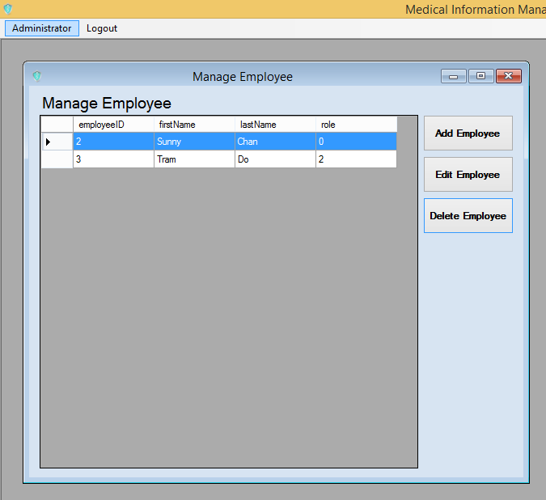

Figure : Manage Employee Box

1. Administrator can add employees
2. Administrator can edit employees (excluding themselves and employeeID #1).
3. Administrator can delete employees (excluding themselves and employeeID #1).

## Add Employee

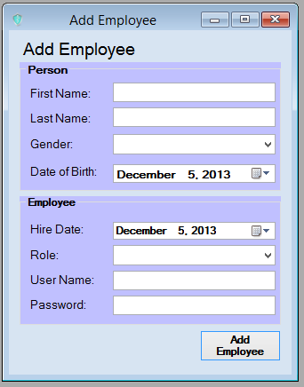

Figure : Add Employee Box

*First Name, Last Name, Role, User Name, Password are require fields.

## Edit Employee

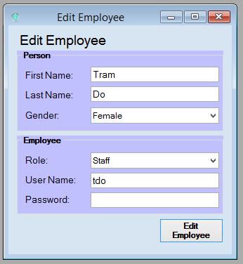

Figure : Edit Employee Box

*First Name, Last Name, Role, User Name, Password are require fields.

## Delete Employee

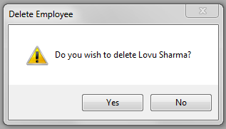

Figure : Delete Employee Dialog

# Database Diagram

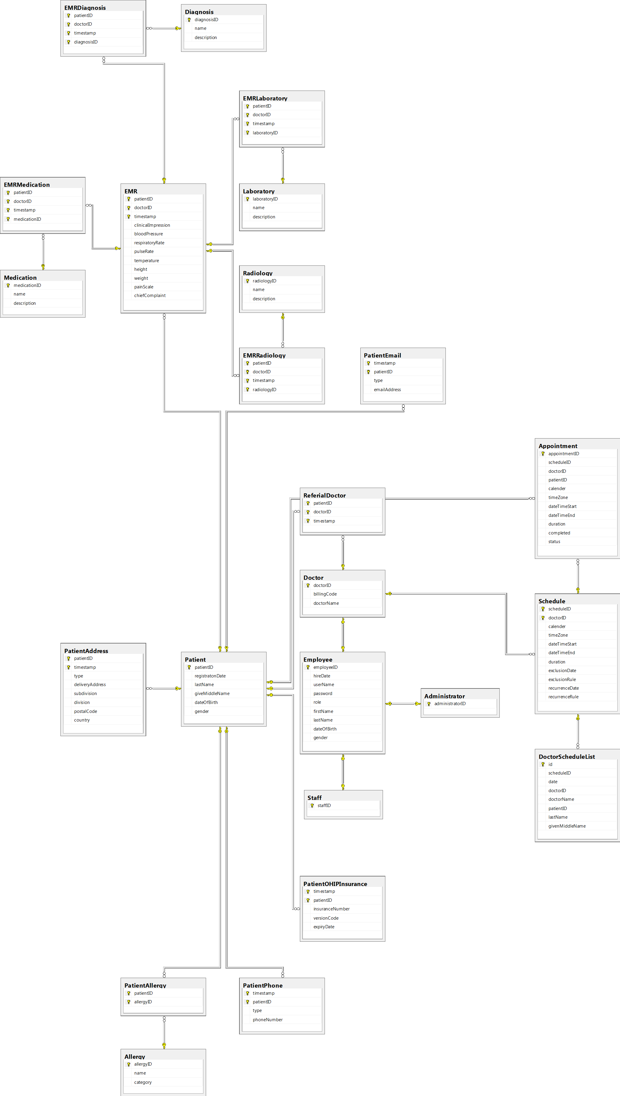

Figure : Database Diagram